Spanning tree
A spanning tree is a subset of Graph G, such that all the vertices are connected using minimum possible number of edges.
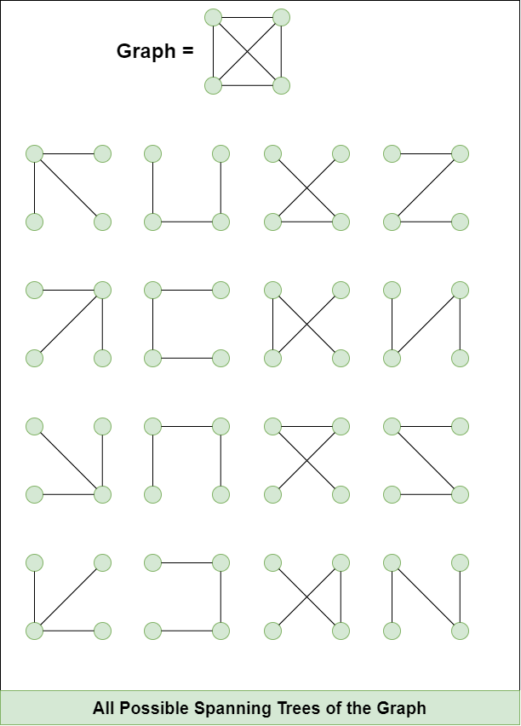

Properties of a Spanning tree:
- For a connected graph having N vertices then the number of edges in the spanning tree for that graph will be N-1.
- A Spanning tree does not have any cycle.

Minimum Spanning Tree
A minimum spanning tree (MST) is defined as a spanning tree that has the minimum weight/cost among all the possible spanning trees.
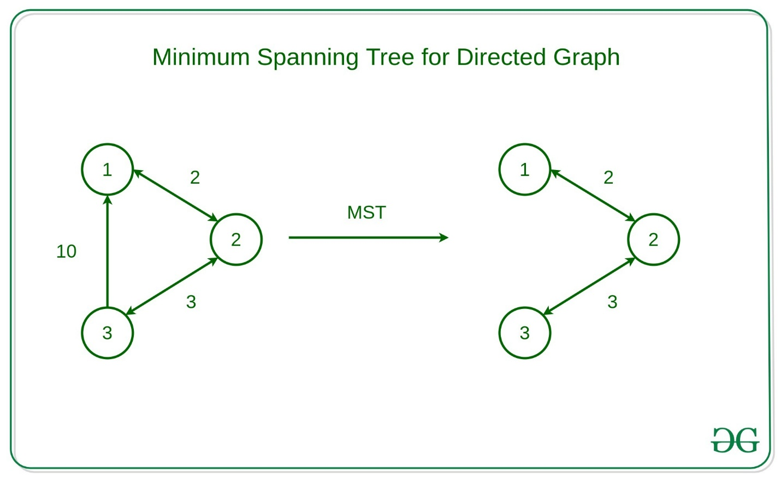
- An MST with V vertices (where V is the number of vertices in the original graph) will have exactly V - 1 edges, where V is the number of vertices.
- Minimum Spanning Tree of a Graph may not be Unique
- An MST is acyclic, meaning it contains no cycles.

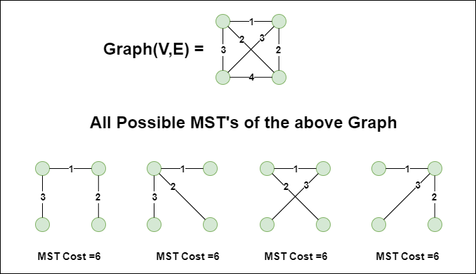

Krushkal's Minimum Spanning Tree
How to find MST using Kruskal's algorithm?
Below are the steps for finding MST using Kruskal's algorithm:
- Sort all the edges in a non-decreasing order of their weight.
- Pick the smallest edge. Check if it forms a cycle with the spanning tree formed so far. If the cycle is not formed, include this edge. Else, discard it.
- Repeat step 2 until there are (V-1) edges in the spanning tree.
How to detect cycles?
Kruskal's Algorithm uses the Disjoint Set Data Structure to detect cycles.
Disjoint Set (Union-Find Algorithm)
Two sets are called disjoint sets if they don't have any element in common.
- Merging two disjoint sets to a single set using Union operation.
- Finding representative/root of a disjoint set using Find operation.
- . We mainly find representative/root of both and check if same.

